

File and directory management is a fundamental operation in any operating system. In Linux, effective handling of files and directories is essential for system administration, software development, and cyber security tasks. Unlike graphical file managers, Linux primarily relies on command-line utilities to create, view, modify, and manage files with precise control over permissions and access rights.
The problem is to practice Linux commands for working with files and directories, understand file and directory permissions, and use basic text editors such as nano and vi to create and edit files in a Linux environment.

Theory

Linux File System
Linux follows a hierarchical file system structure starting from the root directory /. All files and directories are organized in a tree-like structure, enabling efficient file management and security control.

Files and Directories
- Files store data such as text, scripts, or binaries.
- Directories act as containers that organize files and other directories.

File and Directory Permissions
Linux enforces security using a permission model that defines:
- Read (r) – Permission to read file contents or list directory contents
- Write (w) – Permission to modify a file or directory
- Execute (x) – Permission to execute a file or access a directory Permissions are assigned to:
- Owner
- Group
- Others

Commands Used
ls | List files and directories
ls -l | Display detailed file information
pwd | Show current directory
cd | Change directory
mkdir | Create directory
rmdir | Remove empty directory
touch | Create empty file
cat | Display file content
nano | Edit files using nano editor
vi | Edit files using vi editor
chmod | Change file permissions
stat | Display file status

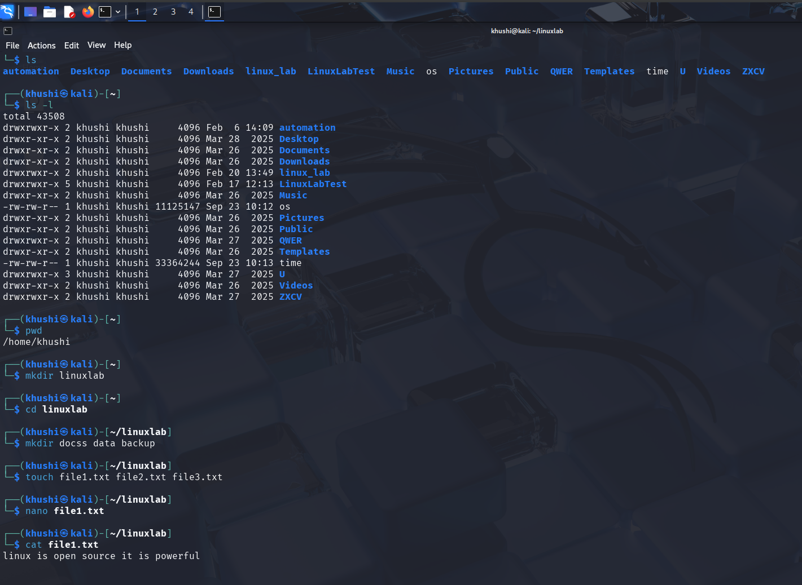

Result
Basic Linux system commands, run levels, and help utilities were successfully explored and executed. The student gained practical understanding of Linux command-line interaction and documentation mechanisms.

